**Library Management System:**

A MINI PROJECT REPORT

Submitted By

RUBEN RAJ L - (220701230)

In partial fulfillment for the award of the degree of

BACHELOR OF ENGINEERING

IN

COMPUTER SCIENCE AND ENGINEERING

RAJALAKSHMI ENGINEERING COLLEGE (AUTONOMOUS) THANDALAM

CHENNAI-602105 2024-2025

**Table of Contents**

1. Introduction
2. Abstract
3. Problem Statement
4. Objectives
5. System Requirements and Scope
6. Software Description and Key Features
7. Programming Languages and Technologies Used
8. Code Implementation
9. Output(UI)

10.Results and Analysis

11.Conclusion

**1. Introduction**

The library sector is increasingly adopting digital solutions to enhance user experiences and optimize operations. Many traditional libraries rely on manual processes for book cataloging, membership management, and feedback collection, which can lead to inefficiencies and errors. As a result, users often face delays and a less seamless library experience, while administrators struggle with limited insights into library performance. This report discusses a **Library Management System (LMS)** that integrates digital book cataloging, online membership management, real-time analytics, and feedback mechanisms to address these challenges. By automating key tasks, the LMS aims to improve user satisfaction and operational efficiency.

**2. Abstract**

This **Library Management System (LMS)** is designed to modernize and optimize library operations. The system focuses on improving three main areas: user experience, operational efficiency, and data-driven decision-making. Key features include online book search and reservations to simplify the borrowing process, a digital catalog with detailed information to showcase the library's collection, a feedback collection system for real-time user insights, and an analytics dashboard that empowers administrators to make informed decisions. By reducing manual errors, streamlining workflows, and collecting actionable feedback, the LMS aims to enhance the library experience for both users and management.

**3. Problem Statement**

The traditional approach to library management presents numerous challenges, primarily due to outdated manual processes. The main issues identified include:

1. **Manual Processes**: Inefficient book borrowing and return systems, along with outdated catalogs, create confusion and reduce user satisfaction. Manual tracking of borrowed items is prone to errors, leading to misplaced books, delays, and user frustration.
2. **Limited Feedback Mechanisms**: Many libraries lack effective methods for gathering and analyzing user feedback. Without this information, administrators miss opportunities to understand user needs, improve services, and address issues proactively.
3. **Operational Inefficiencies**: Manual workflows increase the risk of errors in cataloging, membership management, and inventory tracking, which can lead to service delays and administrative challenges. These inefficiencies hinder the library's ability to provide a seamless user experience and reduce overall productivity.

**4. Objectives**

The **Library Management System (LMS)** is designed with the following objectives:

1. **Streamline Borrowing Processes**
   * Implement an online system for book search and reservations.
   * Reduce manual workloads and minimize errors.
   * Enhance convenience for library users.
2. **Showcase Library Collection**
   * Provide a digital catalog with detailed book information.
   * Include high-quality images of books, journals, and other resources.
   * Help users explore and make informed choices.
3. **Gather User Feedback**
   * Introduce a structured feedback mechanism.
   * Collect real-time insights from users.
   * Enable administrators to address areas for improvement proactively.
4. **Enable Data-Driven Decisions**
   * Offer real-time analytics on reservations and user preferences.
   * Identify popular resources for better resource planning.
   * Support informed decision-making by library management.

**5. System Requirements and Scope**

**Functional Requirements**

1. **Online Book Reservation System**
   * Allow users to search for books and reserve them online.
   * Display real-time availability of books and provide instant reservation confirmations**.**
2. **Digital Catalog**
   * Provide a visually appealing catalog with detailed book descriptions and images.
   * Showcase the library's collection in an organized and user-friendly format.
3. **Real-Time Analytics Dashboard**
   * Offer administrators insights into borrowing patterns, popular books, and membership trends.
   * Support data-driven decisions for improving library services.
4. **Feedback Collection System**
   * Enable users to submit feedback on services and resources.
   * Allow management to analyze feedback trends to enhance service quality.

**Non-Functional Requirements**

1. **Performance**
   * The system should handle high traffic during peak times, such as exam seasons or new membership drives.
2. **Security**
   * Ensure robust data protection and compliance with privacy regulations to safeguard user information.
3. **Usability**
   * Provide intuitive interfaces for users, library staff, and administrators, ensuring ease of use across all functions.

**Scope**

The Library Management System (LMS) focuses on core functionalities such as book reservations, catalog management, analytics, and feedback collection. It does not cover administrative back-end tasks like supplier management or financial accounting

**6. Software Description and Key Features**

The **Library Management System (LMS)** includes various features to address both user needs and operational efficiency:

* **Online Book Reservation**
  + Allows users to reserve books through a web interface or mobile app.
  + Provides real-time book availability, enables selection of desired titles, and generates instant reservation confirmations.
* **Digital Catalog**
  + A visually appealing catalog system that showcases books with high-quality images, descriptions, and categorization.
  + Includes special sections for highlighting newly added or popular books to enhance user engagement.
* **Feedback System**
  + Enables users to provide feedback on library services and resources.
  + Management can analyze this feedback to identify trends and improve overall service quality.
* **Real-Time Analytics**
  + A dashboard provides administrators with insights into borrowing patterns, popular books, and peak usage times.
  + Facilitates data-driven decisions to enhance library operations and resource management.

**7. Programming Languages and Technologies Used**

* **Frontend:** HTML, CSS, JavaScript and Boootstrap are used to build responsive and user-friendly interfaces. Libraries such as React or Angular may be used for dynamic content rendering.
* **Backend:** Python, PHP as the backend framework to manage server-side operations, data processing, and logic.
* **Database:** MySQL is used for efficient data storage, supporting information such as customer records, reservations, orders, and feedback.
* **APIs and Libraries:** Integration of third-party libraries for data visualization, authentication, and analytics enhances the system's functionality.

**8.Output (UI)**

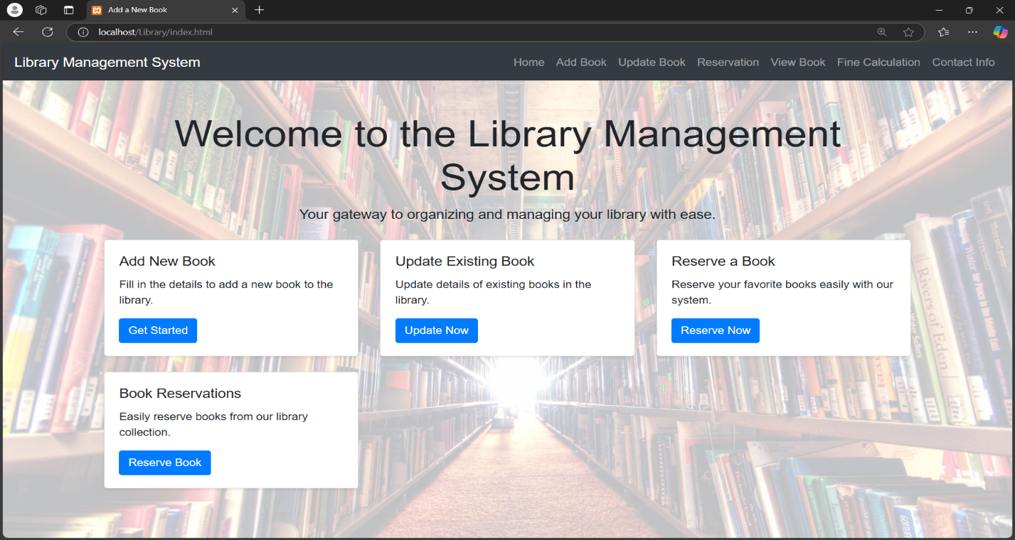

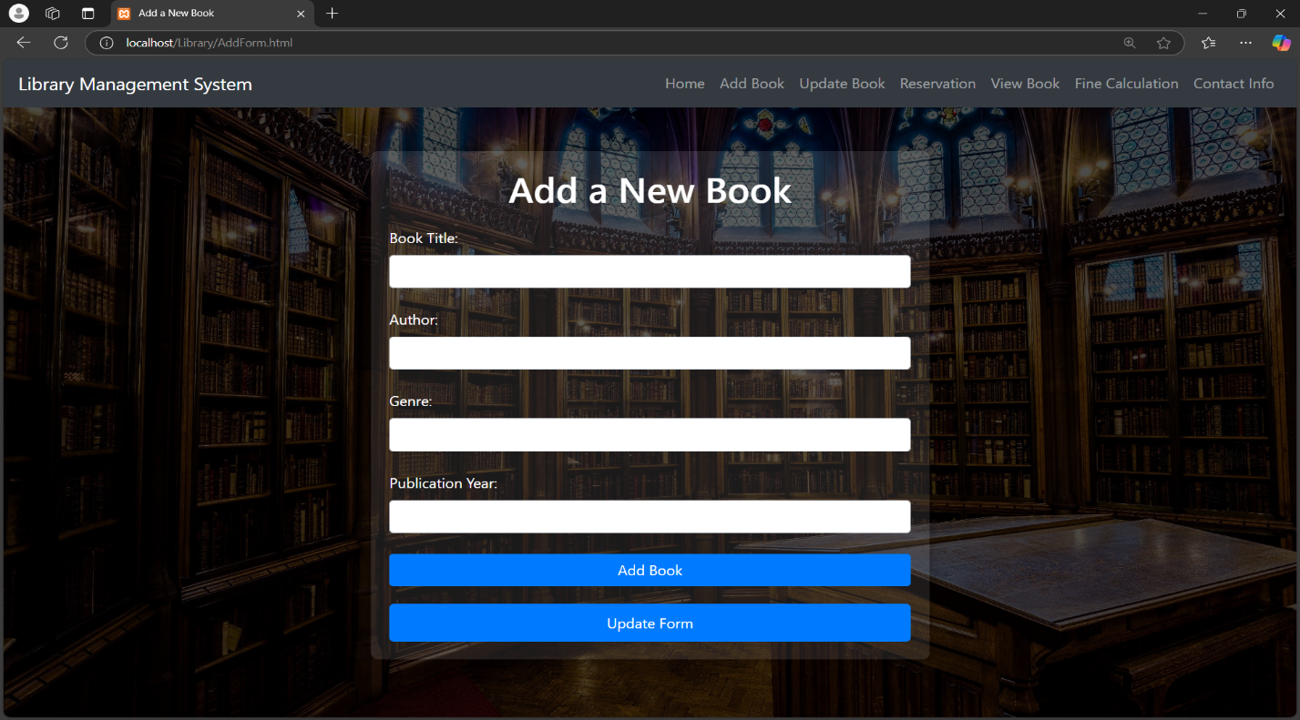

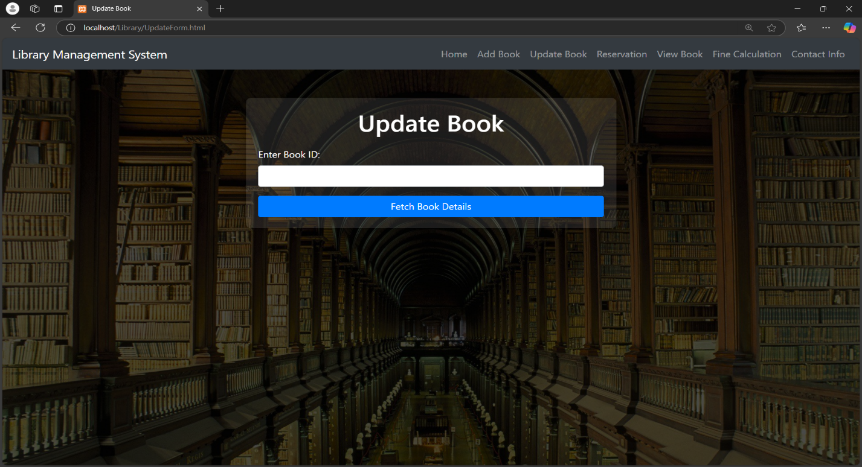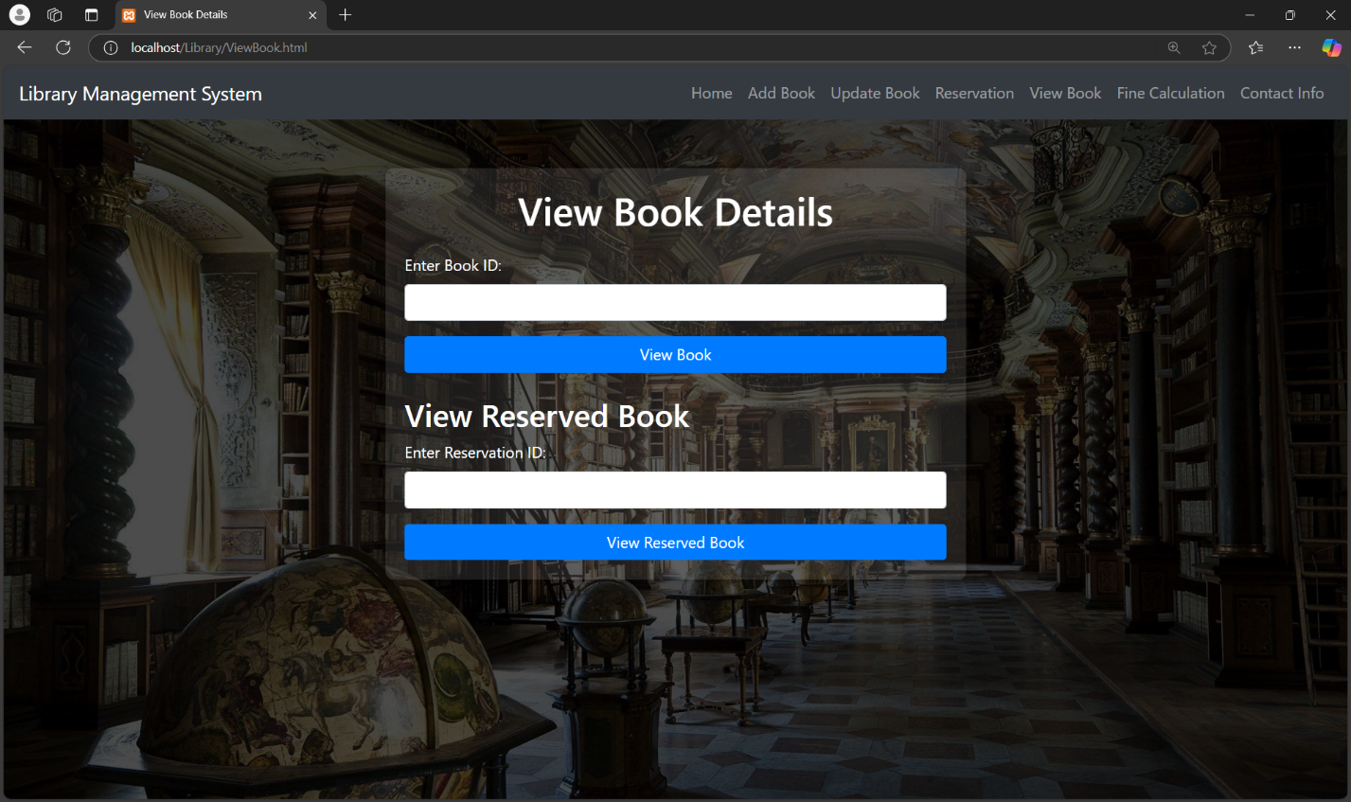

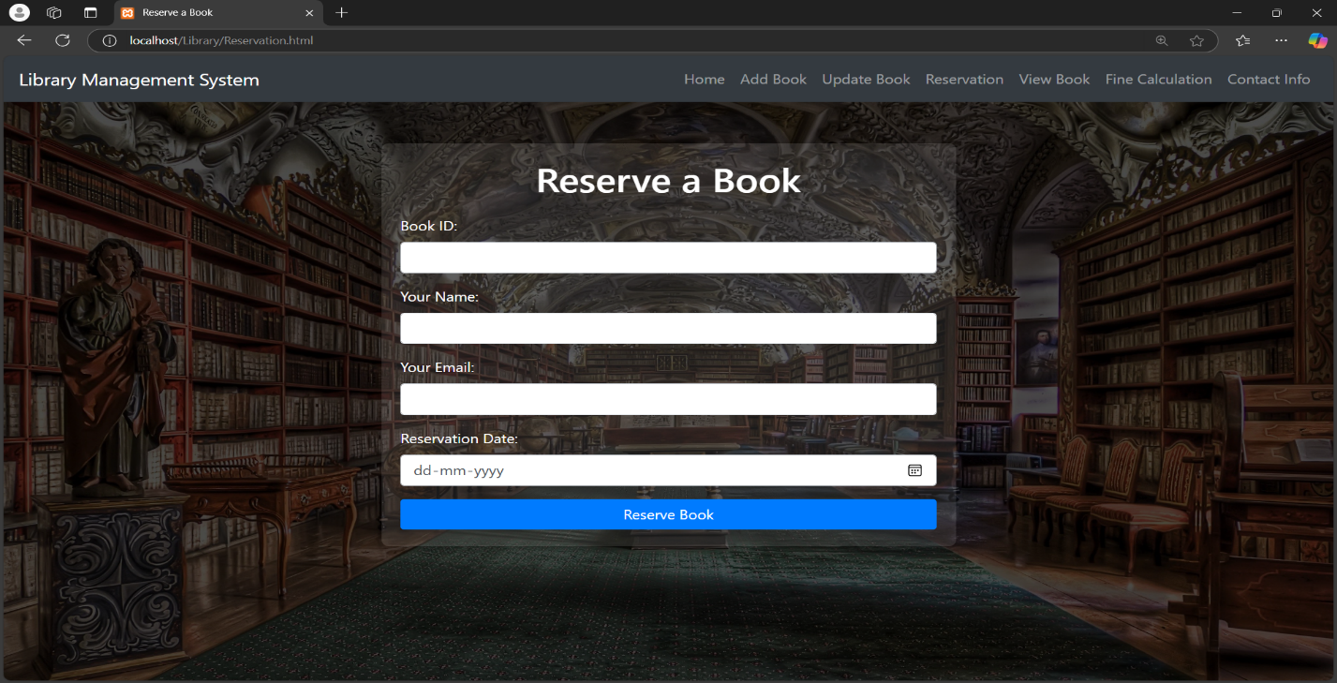

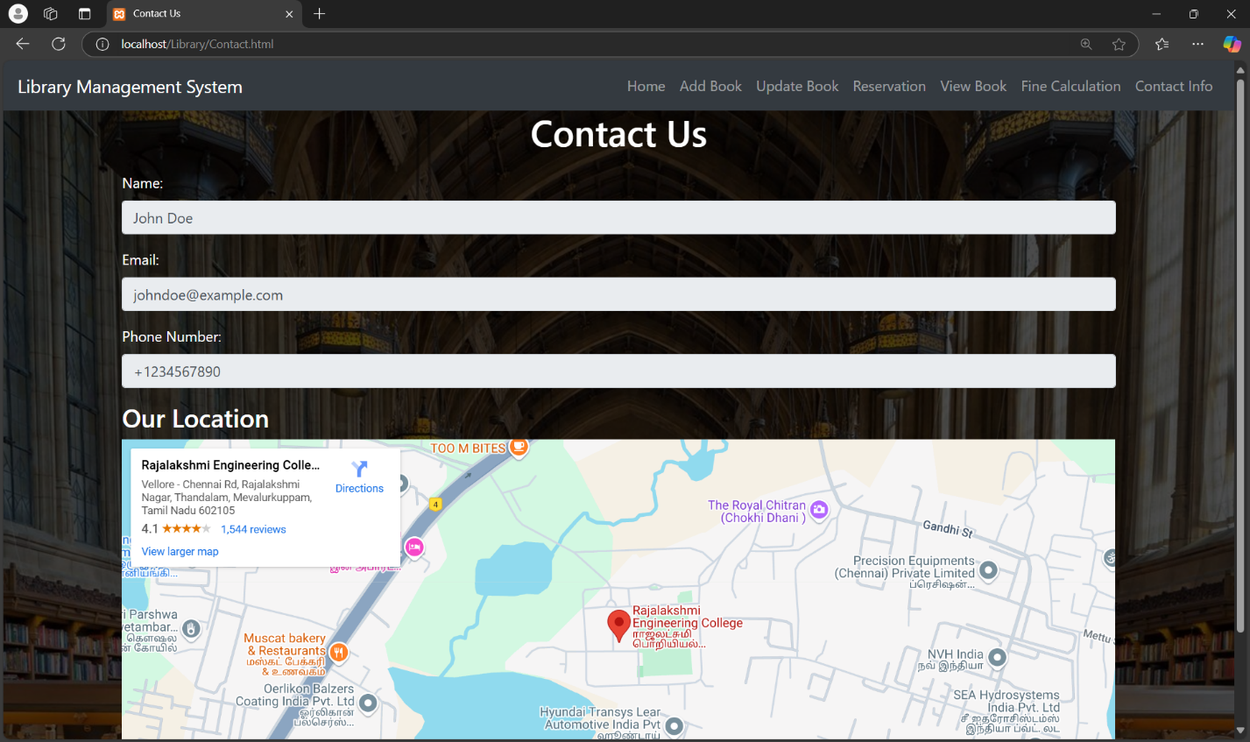

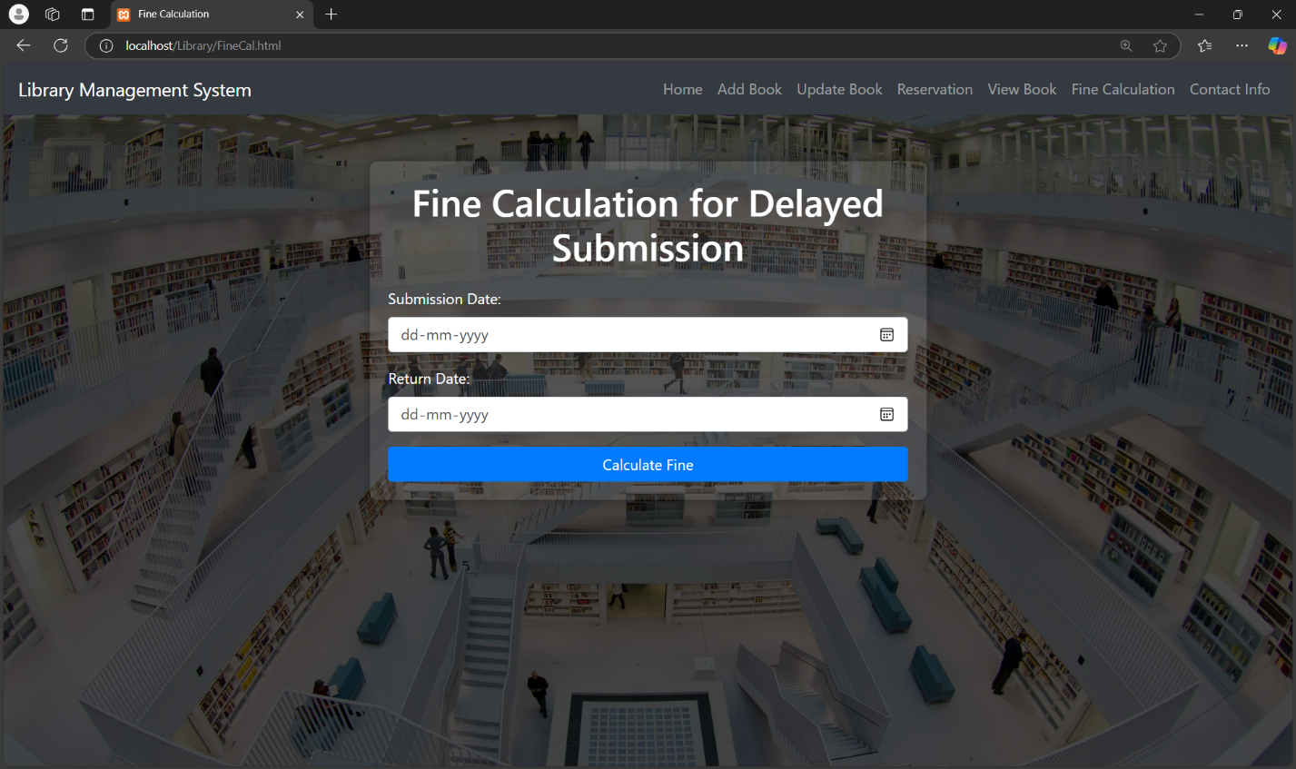

**9. Results and Analysis**

The implementation of the **Library Management System (LMS)** has shown promising results in improving library operations and user experience. Key outcomes include:

* **Enhanced Efficiency**
  + The online book reservation system reduces manual errors and streamlines the borrowing process, leading to quicker access to books and a smoother user experience.
* **Improved User Satisfaction**
  + Feedback indicates that users value the digital catalog for its detailed information and the convenience of online reservations.
* **Data Insights**
  + The analytics dashboard helps administrators track borrowing trends, popular books, and peak library usage times, enabling informed decision-making to enhance services.

**10. Conclusion**

The **Library Management System (LMS)** effectively addresses common challenges in library management by automating book reservations, providing a digital catalog, and enabling user feedback collection. By offering real-time analytics and streamlining workflows, the LMS enhances operational efficiency and user satisfaction. Future enhancements could include integration with personalized reading recommendations, AI-driven book suggestions, and mobile app support. This project highlights the potential of technology to transform traditional library operations, making them more efficient, insightful, and user-friendly.